Gaussian Software

Challenge 1:

Reactant and product are acetone and propenal

Acetone Propenal

Steps:

1. A picture containing sky, metal, bunch, table

   Description automatically generated 2. 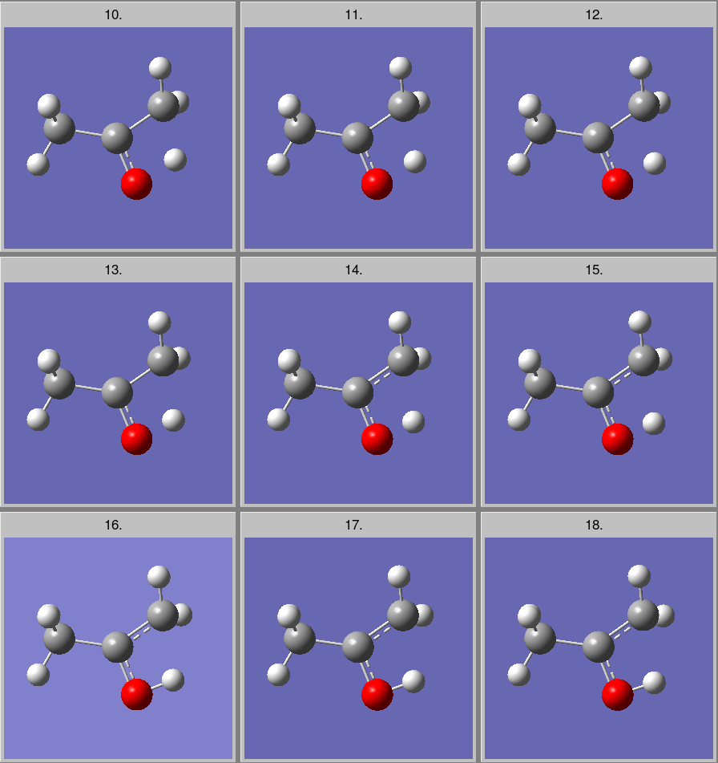

3. 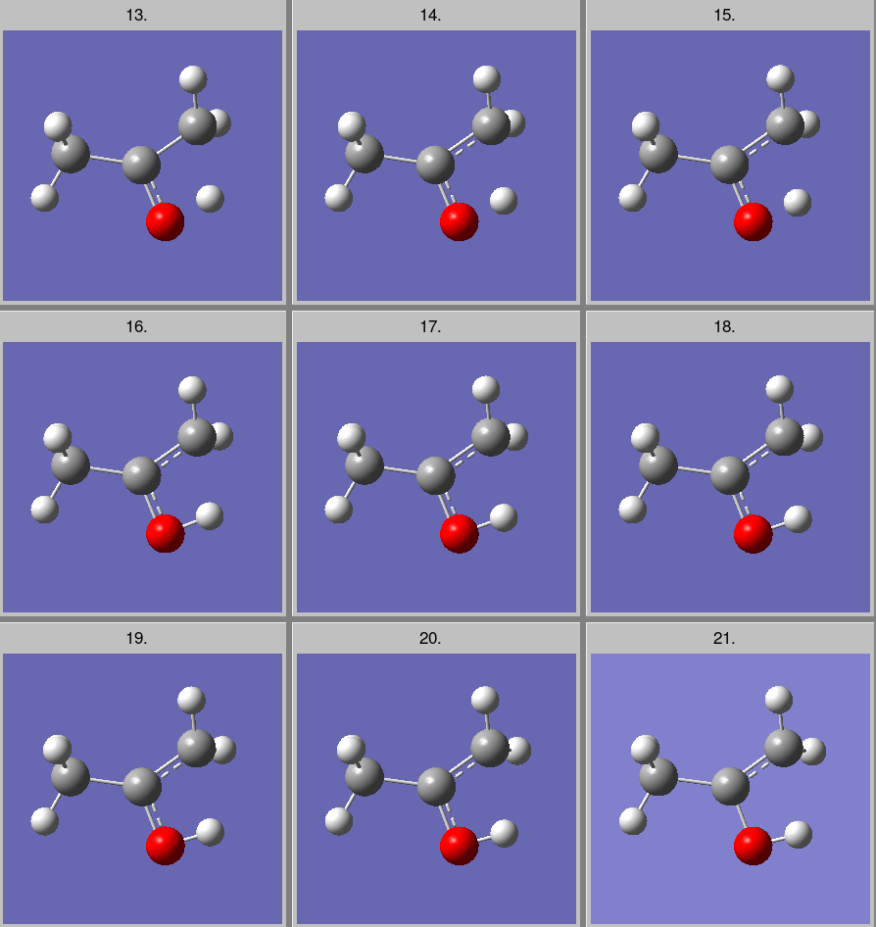 4. 

Graph:

The difference between energies of reactants and products is 0.04 Hartree or 25.1004 kcal per mole.

The energy of transition state is 118,831.5687 kcal per mole.

Here, acetone is more stable than propenal.

Challenge 2:

The energies of the 9 isomers of c11H 22 are plotted in the following graph. It depicts that isomer 2 has more energy than the rest and that isomer 6 is most stable.

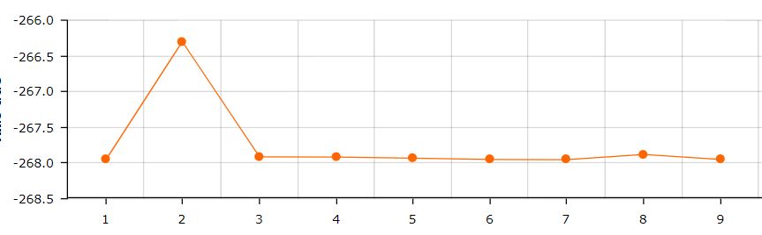

The structures of the 9 isomers are the following in order:

Challenge 3:

Dihedral scans of n hexane along different atoms as given

Scan done for 180 degrees

3. 1 .1: staggered form of the given scan

3.1 .2: Gauche form of given scan

3.1.3: Eclipsed form of the given scan

3.1: scan graph of energies

The staggered form is most stable form

The gauche form is moderately stable

The eclipsed form is least stable out of the three

3. 2.1: staggered form of the given scan

3.2.2: gauche form of the given scan

3.2.3: eclipsed form of the given scan

3.2: scan graph of energies

The staggered form is most stable

The gauche form is moderately stable

The eclipsed form is least stable

3.3.1: staggered form of the given scan

3.3.2: gauche form of the given scan

3.3.3: eclipsed form of the given scan

3.3: graph of the given scan/ potential energy diagram

The staggered form is highly stable

The gauche form is moderately stable

The eclipsed form is least stable of all three

Challenge 4:

Ethanol structure:

The vibration IR spectrum

Original spectrum:

The peaks of this ethanol represent the respective vibrations that are with respect to the wavenumbers given in the graph. These are the vibrations that have maximum frequency. These are the vibrations that happen majorly with respect to hydrogens. Due to the less mass and more freedom of hydrogens, they have a higher frequency.

Challenge 5:

Energy diagram of **HNC-+HCN**

The referance graph

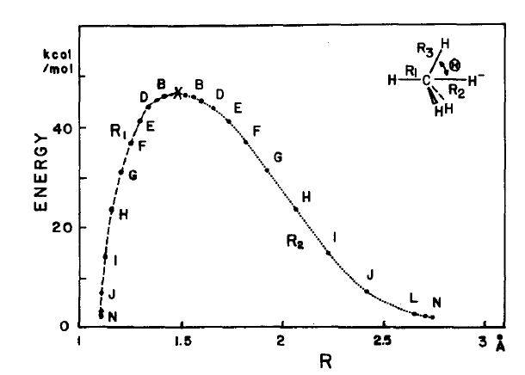

The position of the carbon atom moves only slightly during the reaction, and only the two extreme positions are shown. The position of the hydrogen atom at the transition state is shown by H. The hydrogen atom moves smoothly from the left-hand side, which corresponds to HNC, through the transition state to the right-hand side (HCN).

Here, the saddle point is the transition state. The hydrogen moves from the nitrogen atom to carbon atom across this transition state. The Activation energy of this reaction is approximately 91.565 RHF or 61,578.37815 kcal/mol.